GitHub Actions
- GitHub Actions is a continuous integration and continuous delivery (CI/CD) platform that allows to automate your build, test, and deployment pipeline.
- You can create workflows that build and test every pull request to your repository or deploy merged pull requests to production.
- GitHub Actions lets you run workflows when other events happen in your repository.
- For example, you can run a workflow to automatically add the appropriate labels whenever someone creates a new issue in your repository.
- GitHub provides Linux, Windows, and macOS virtual machines to run your workflows, or you can host your own self-hosted runners in your own data center or cloud infrastructure.

The components of GitHub Actions

- Workflow

- A workflow is a configurable automated process that will run one or more jobs.
- Workflows are defined by a YAML file checked in to your repository.
- Workflows are defined in the .github/workflows directory in a repository.
- A repository can have multiple workflows, each of which can perform a different set of tasks.

- Event

- An event is a specific activity in a repository that triggers a workflow.
- An activity can originate from GitHub when someone creates a pull request, opens an issue, or pushes a commit to a repository.

- Job

- A job is a set of steps in a workflow that is executed on the same runner.
- Each step is either a shell script that will be executed, or an action that will be run.
- Steps are executed in order and are dependent on each other.
- each step is executed on the same runner, you can share data from one step to another
- You can configure a job's dependencies with other jobs
- Jobs have no dependencies and run in parallel
- You can also use a matrix to run the same job multiple times.

- Step

- A step is an individual task within a job. Steps can execute commands or use predefined actions.

- Action

- An action is a pre-defined, reusable set of jobs or code that performs specific tasks within a workflow.
- Reduce the amount of repetitive code you write in your workflow files.
- You can write your own actions.
- you can find actions to use in your workflows in the GitHub Marketplace.

- Runner

- A runner is a server that runs your workflows when they're triggered.
- Each runner can run a single job at a time.
- GitHub provides hosted runners (Linux, Windows, macOS) to run your workflows.
- Each workflow run executes in a fresh, newly provisioned virtual machine.
- GitHub also offers larger runners, which are available in larger configurations.
- you can host your own runners.
- Runner = Execution Environment
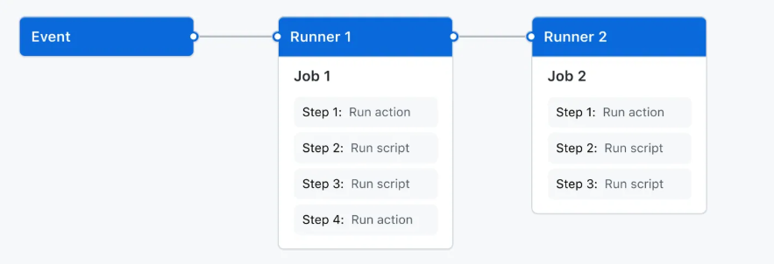

When an event (like a push or pull request) happens, it triggers a workflow that contains multiple jobs. Each job runs on a separate runner (a temporary virtual machine provided by GitHub). Inside each runner, the job executes multiple steps, and those steps run one after another in sequence. However, different jobs can run in parallel on different runners, which makes the process faster and more efficient.

GitHub Actions can help you automate nearly every aspect of your application development processes.

